Belgium
68% of respondents were women. 30% were immigrants. 20% identified as people of color.

8% work some night shifts. 32% exclusively work day shifts.

20% work more than one job. 10% work more than 40 hours a week.

40% sometimes feel isolated at work. 30% sometimes feel unsafe.

25% say they have been harassed at work, and 12% have been harassed while commuting.

Around 40% of Belgian cleaners surveyed either disagree or strongly disagree with the statement: “I have control over my work schedule”. Overall, as the figure below shows, Belgian workers are less likely than cleaners in other countries to feel they have control over their schedules.

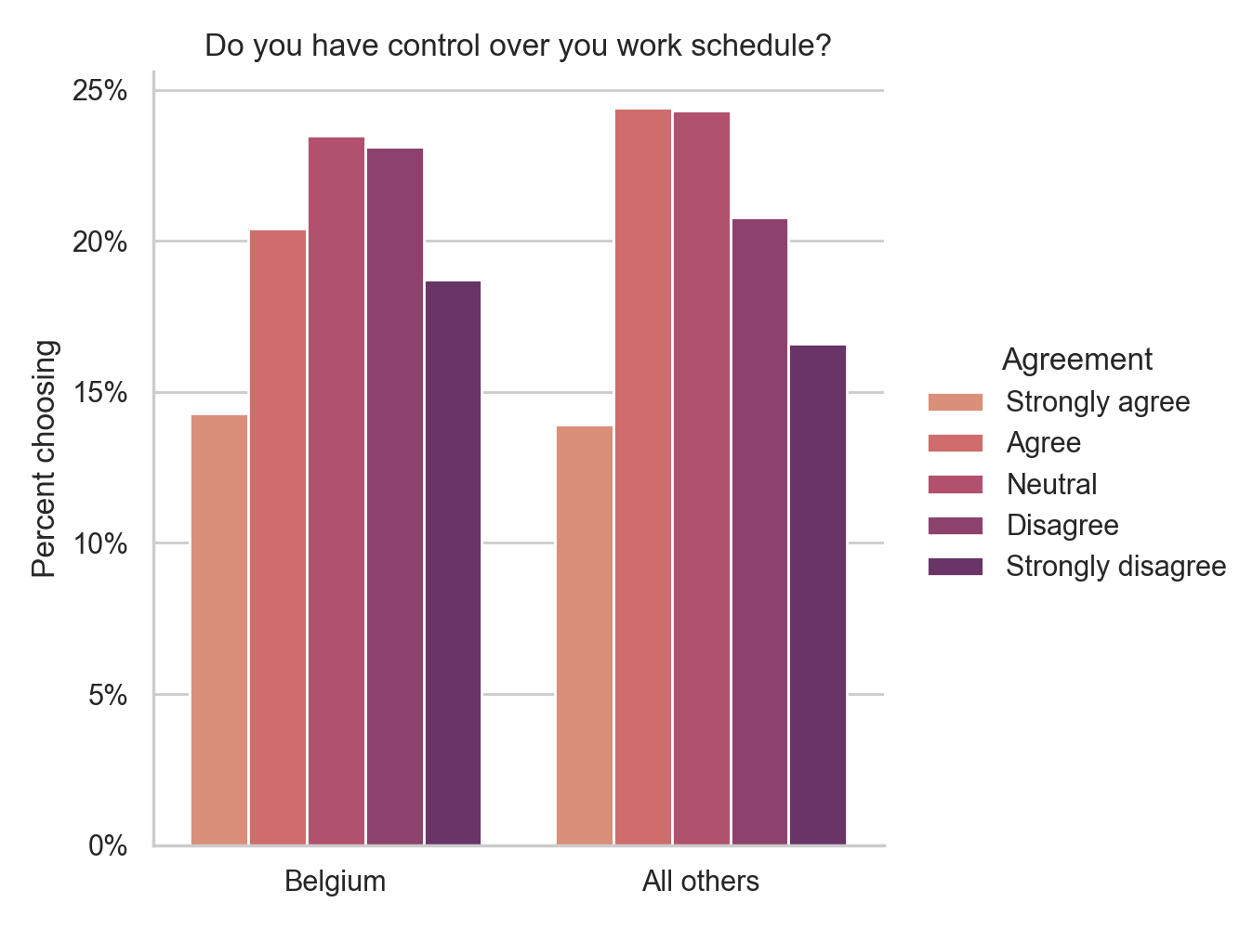

68% of Belgian cleaners who work shifts other than the day shift said they would like to exclusively work day shifts. As the figure below shows, family scheduling conflicts and a lack of availability of day shifts are the biggest factors keeping Belgian respondents from exclusively working day shifts.

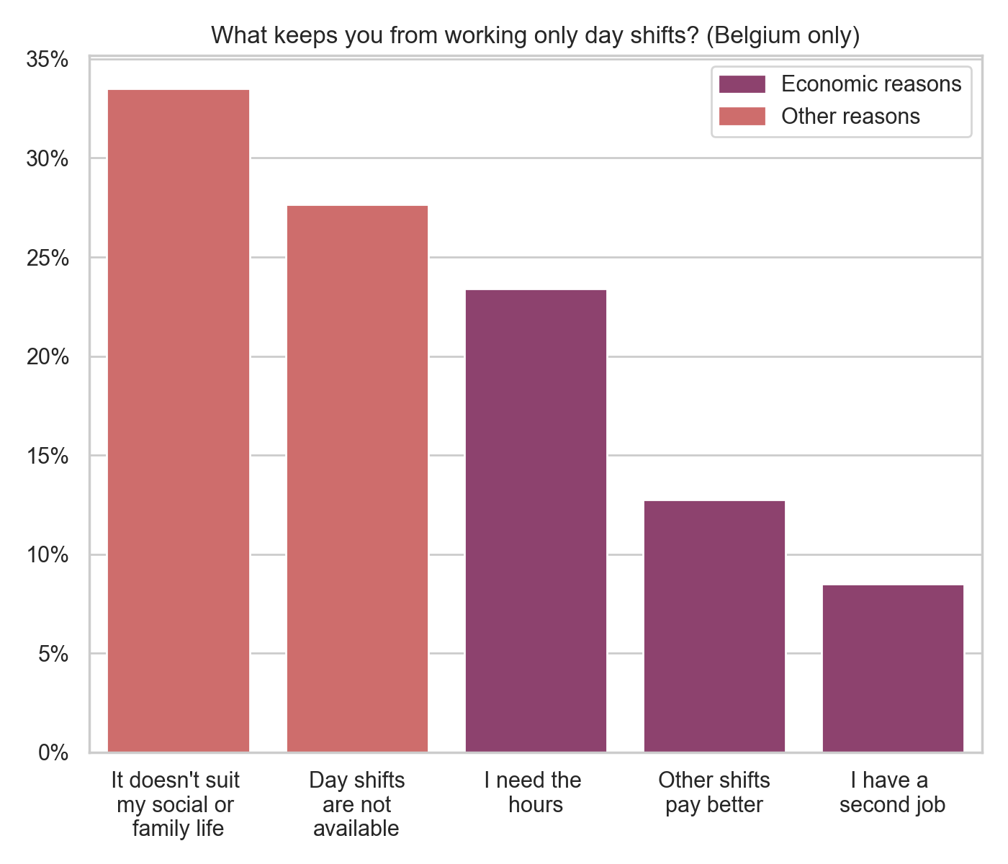

The Netherlands
57% of respondents were women. 63% were immigrants. 31% identified as people of color.

15% work some night shifts. 28% exclusively work day shifts.

17% work more than one job. 10% work more than 40 hours a week.

38% sometimes feel isolated at work. 26% sometimes feel unsafe.

29.5% say they have been harassed at work, and 15% have been harassed while commuting.

Compared to the dataset as a whole (see figure below), Dutch cleaners were more somewhat more likely to feel they have control over their schedules. Around 27% of Dutch cleaners surveyed either disagree or strongly disagree with the statement: “I have control over my work schedule”. With respect to cleaners in other countries, many fewer Dutch cleaners indicated that they “strongly disagree” with the statement (7.5% vs. 17%).

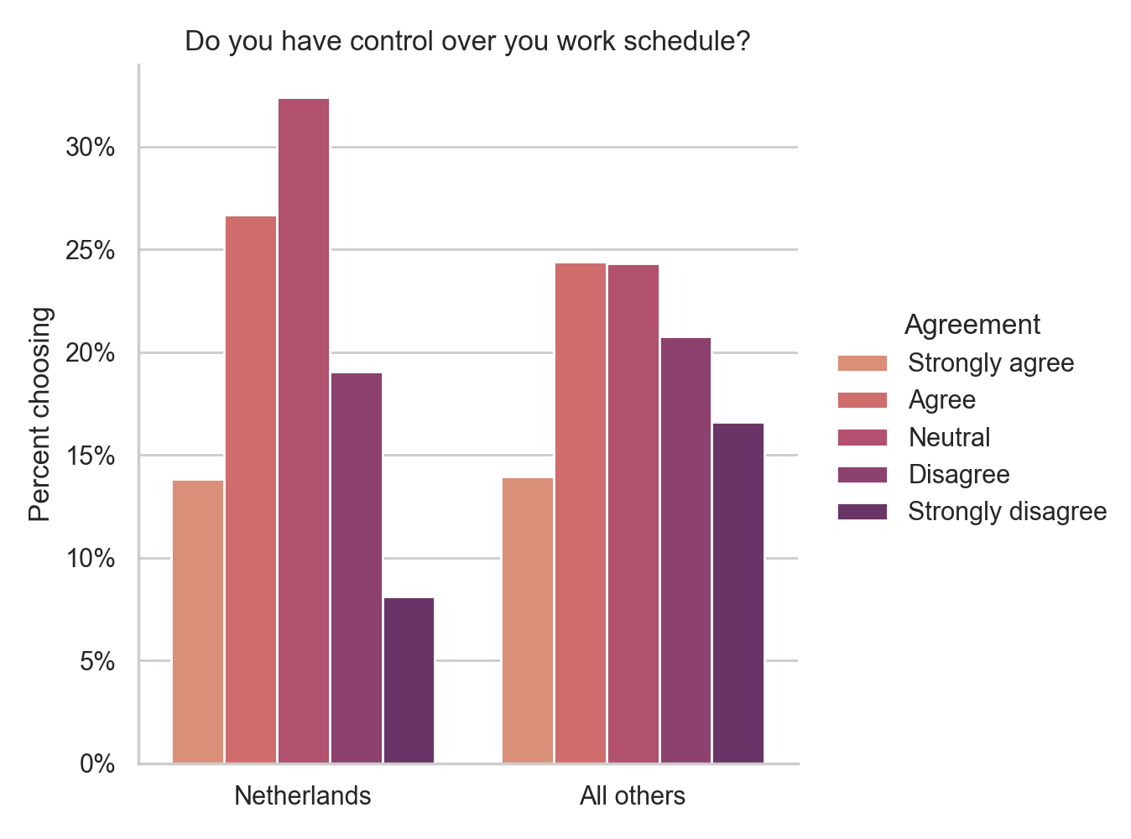

52% of Dutch cleaners who work shifts other than the day shift said they would like to exclusively work day shifts. As the figure below shows, family or social scheduling conflicts was the biggest factor keeping Dutch respondents from exclusively working day shifts, but the need for hours and lack of availability of day shifts were both almost just as significant.

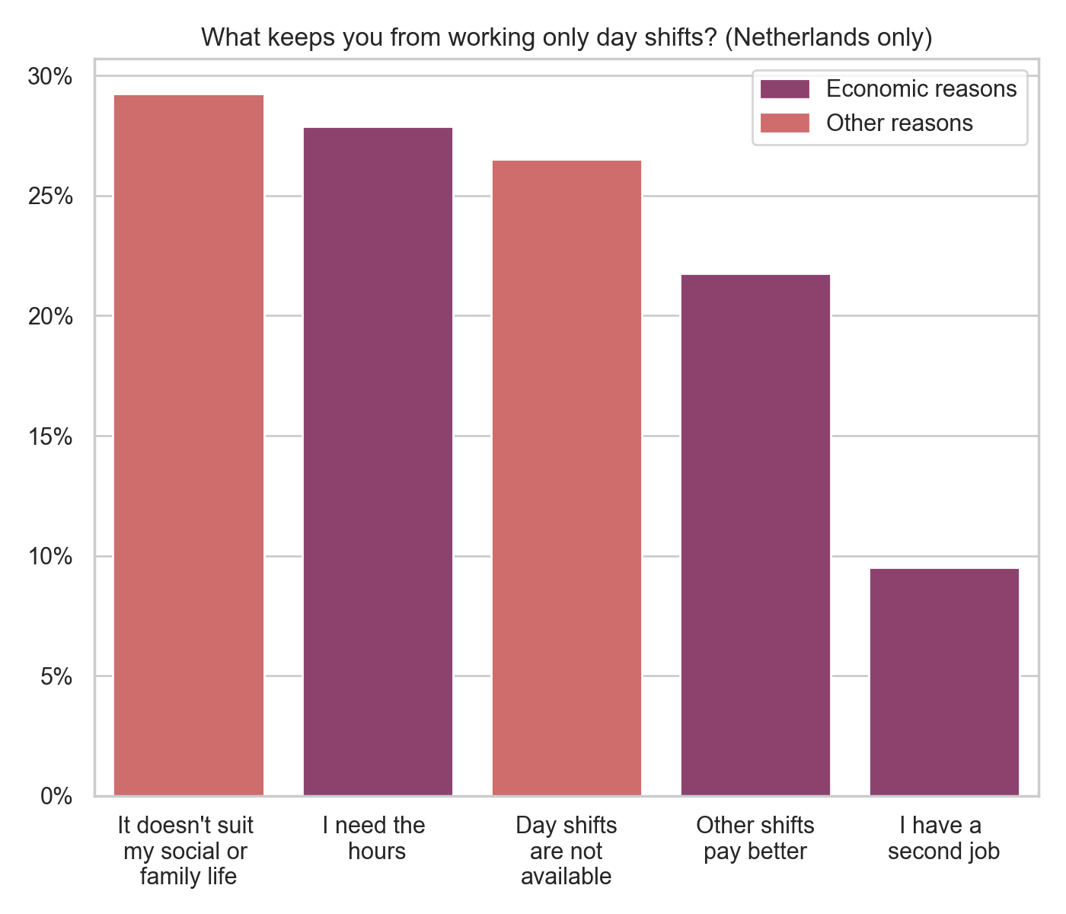

Germany
73% of respondents were women. 16.5% were immigrants. 8% identified as people of color.

9% work some night shifts. 30% exclusively work day shifts.

28% work more than one job. 22% work more than 40 hours a week.

54% sometimes feel isolated at work. 28% sometimes feel unsafe.

21% say they have been harassed at work, and 11.5% have been harassed while commuting.

Compared to the dataset as a whole (see figure below), German cleaners were somewhat more likely to feel they have control over their schedules. Around 34% of German cleaners surveyed either disagree or strongly disagree with the statement: “I have control over my work schedule”. With respect to cleaners in other countries, many fewer German cleaners indicated that they “strongly disagree” with the statement (10% vs. 17%).

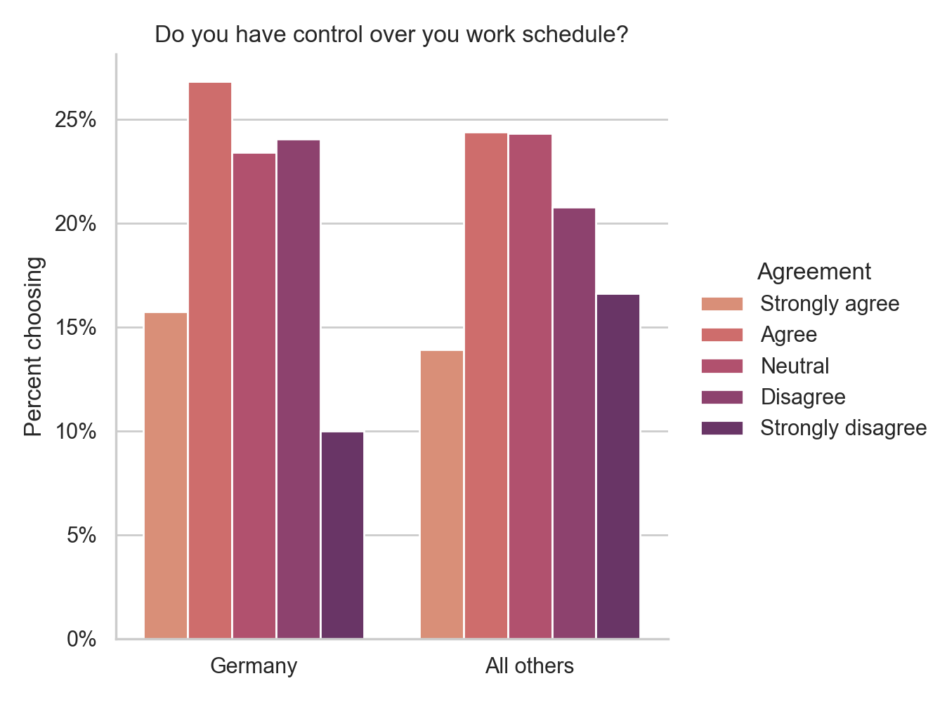

69.5% of German cleaners who work shifts other than the day shift said they would like to exclusively work day shifts. As the figure below shows, the biggest factor by far keeping German respondents from exclusively working day shifts was the simple need to work more hours.
